1. Model implementation
2. LSTM

Epochs = 40

Training time = 16 sec

Accuracy = 0.7894737124443054

number of parameters = 211506

training loss curve =

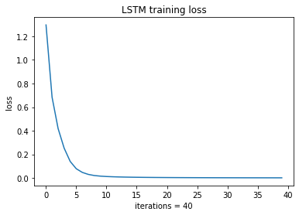

1. EEGNet

Epochs = 40

Training time = 21 sec

Accuracy = 0.9802631735801697

number of parameters = 2,406

training loss curve =

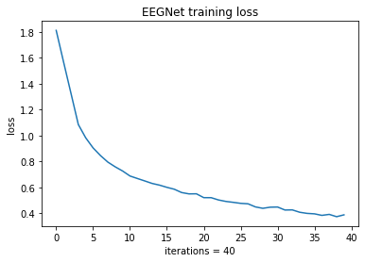

1. Model competition

我選擇EEGNet，因為它的validation accuracy比LSTM高出非常多